# Introduction

## Formula Student

Formula Student is an international student engineering competition. Teams from all over the world design and build a small-scale Formula-style racing car. During the competitions, the cars are judged on static events: Engineering Design, Cost & Manufacturing, Business Presentation, Lap Time Simulation, and Technical Inspection. The vehicle must comply with the rules [1] for the technical inspection. If the car passes the technical inspection, it can participate in the dynamic events: Skidpad, 1 km autocross/sprint, 75 m acceleration, and 22 km endurance.

Figure 1: Formula Student Endurance race

## Valais-Wallis Racing team

## The Valais-Wallis Racing team [2] is the formula student team of the HES-SO Valais Wallis. It was created in the spring of 2022 by a group of students. The team’s first car will take part in the races of summer 2023, and the telemetry system developed in this thesis will be used on the next car for the races of summer 2024.

## Objectives

Telemetry is a technology that enables remote measurement and monitoring. This technology is interesting for a race vehicle as it allows live readings from the car's sensors to be read directly from the side of the track. With such a system, the data from all the sensors is easily accessible, and the engineers can adjust the car's parameters during the test sessions to increase the car's performance. A telemetry system is also helpful in improving the driver's skills, providing measurements such as GPS, speed, pedal level, steering angle, Etc. Direct visualization of measurements also allows problems to be identified before they can cause an accident.

This project aims to develop and test a telemetry system for the Formula Student car of the HES-SO Valais-Wallis. This thesis deals with the embedded part of the system and the communication with the PC. This project will be carried out in collaboration with a Business Information Technology student working on the software to display the telemetry system's data.

For this work, the reference race is Formula Student Alpe Adria [3] in Croatia. On this circuit, the maximum distance between the car and the base station will be less than 300 meters. The minimum range of the system must therefore be 300 meters, ideally 500 meters.

Figure 2: Alpe Adria Circuit

The telemetry device must communicate via the car's CAN bus with the sensors, the BMS, and the Inverter. A GPS must be integrated into the system. A transmission technology must be chosen for the direct visualization of the data, and the system must also store the data on a microSD card.

## State of the art

Telemetry is used in many systems that require real-time remote measurement and monitoring. The telemetry needs to be embedded in a vehicle for this use case. Racing cars often incorporate telemetry systems, but these are proprietary systems unavailable on the market. That's why the Valais-Wallis Racing Team needs its own telemetry system.

Sensors are the fundamental elements of a telemetry system. All sensors must be connected to the telemetry system. The CAN bus is the standard protocol used in the automotive industry for this purpose. CAN bus (Control Area Network Bus) is a communication protocol that enables reliable and efficient data transfer between ECUs (Electronic Control Units) and sensors. It is a multiplexed bus and was introduced to reduce the amount of copper in cars by wiring all the ECUs and sensors on the same bus. It has been standardized with ISO 118987.

The transmission process is the other key point of the telemetry system. Many transmission processes could be used for this purpose. A standard 433 MHz RF transmission can send data through the air at a reasonable range. Many wireless devices use this transmission method with a dedicated protocol. Otherwise, there are many transmission protocols used for remote data transmission. For example, Wi-Fi is one of the most common transmission protocols. Every laptop, smartphone Etc, uses it. LoRaWAN is a protocol used with LoRa technology that enables long-range communication. Many IoT (Internet of Things) applications use this protocol to communicate.

The last component of a Telemetry system is the processing unit. The processing unit on almost every telemetry system is a software on a PC. The processing unit displays for the user and allows him to analyze the measurements made by the sensors and transmitted by the telemetry system. The processing units could also be linked with a database to store the data at the end of every test session or race.

## Planning

This schedule shows the project's progress over time. The first two weeks were devoted to the transmission technology study. The next three weeks were devoted to developing the electronic board. The fourth week in the "Hardware" section corresponds to the time to manufacture the electronic board. The remaining time was devoted to programming the telemetry system. A detailed schedule is available in the appendix.

# Transmission technology

A wireless transmission must be established from the car to the computer. The range of the telemetry system must be greater than 300 meters (ideally 500 meters) with no obstacle between the transmitter and the receiver.

For this transmission, two technologies were studied. A Wi-Fi connection and a 433 MHz RF transmission.

LoRa protocol and 4G/5G cellular networks were not considered, as the bandwidth is not enough for the first, and there is no guarantee of network coverage in the race locations for the second.

## 433 MHz RF

The first option is a standard RF transmission. This solution is easy to implement, the range is wide enough, and the bandwidth is sufficient for the small amount of data to be sent. Moreover, there is no need to establish a connection. The transmitter emits the data on a frequency, and the receiver listens to the same frequency. If the transmission is interrupted, the data transmission will instantly work once the signal is recovered. With Wi-Fi communication, the car will need to reconnect to the hotspot, which takes a little time.

However, there will be a lot of teams during the competition, and if other teams use the same transmission method, all systems will disturb each other, and the transmission will not be guaranteed.

For an RF transmission, the RFM69HCW [4] module from HopeRF is one of the best options for this use case. It is available in 433 MHz and 868 MHz.

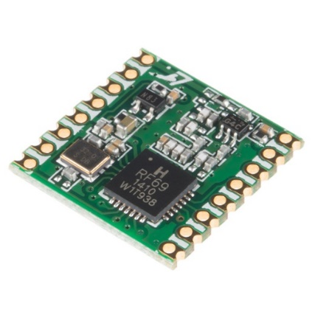

Figure 3: RFM69HCW module

This module has an output power of +20 dBm and an input sensitivity of -120 dBm at 1.2 kbps. The theoretical range can be calculated with the Friis transmission equation [5] (with omnidirectional antennas → Gantenna = 0 dbi):

$$P_{r}=P_{t}+20*log⁡(\frac{λ}{4πd})$$

For the 433 MHz module, the received power is -54 dBm at 500m, which is more than enough for the input sensitivity of -120 dBm.

## Wi-Fi

The second option is a Wi-Fi connection. It is a robust protocol that allows the transfer of large amounts of data. With a Wi-Fi connection, a classic router can be used to connect the telemetry system to the computer and directly send IP packets. Moreover, the system will not have to manage interference from other teams because the Wi-Fi protocol uses carrier-sense multiple access with collision avoidance (CSMA/CA). This method shares the band between the stations to avoid collisions between frames.

The only disadvantage of Wi-Fi communication is the range, which will be more difficult to reach.

The best option for Wi-Fi communication is the nRF7002 [6] chip from Nordic Semiconductors. It is a dual-band Wi-Fi module with an SPI/QSPI interface to relate to a host SoC.

Figure 4: nRF7002 chip

On the 2.4 GHz band at 1 Mbps, the maximum output power is 21 dBm, and the input sensitivity is -98.6 dBm.

The theoretical range can be calculated with the Friis transmission equation [5] (with omnidirectional antennas → Gantenna = 0 dbi):

$$P_{r}=P_{t}+20*log⁡(\frac{λ}{4πd})$$

For the 2.4 GHz band, the received power is -70 dBm at 300 m, which is close to the input sensitivity of a traditional router.

As these equations give theoretical results, tests must be carried out to determine whether the range will be sufficient in practice.

### Tests

## The aim of this test is to determine if a Wi-Fi connection is suitable for the required range. The tests have been carried out in the 2.4 GHz frequency band.

The router used in this test is an Asus RT-AC68U. The router's technical specifications do not mention the output power, but it does have the CE mark, which means that the output power should not exceed 20 dBm. On the opposite side, a laptop was used. It is equipped with an Intel Wi-Fi 6 AX201 module [7], which has similar performances (in terms of range) as the nRF7002 [6]. The test was realized with the default omnidirectional antennas, so there is room for improvement using sector antennas if needed.

The tests were performed with the iPerf software [8], using the UDP protocol at 1 Mbps.

The laptop and the router could communicate successfully at 400 meters distance.

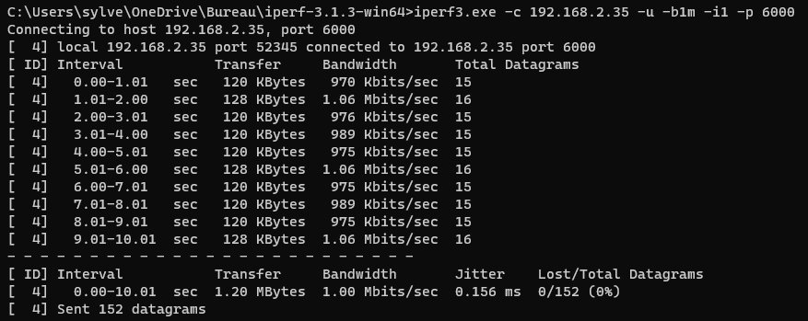

Figure 5: iPerf test - Client side

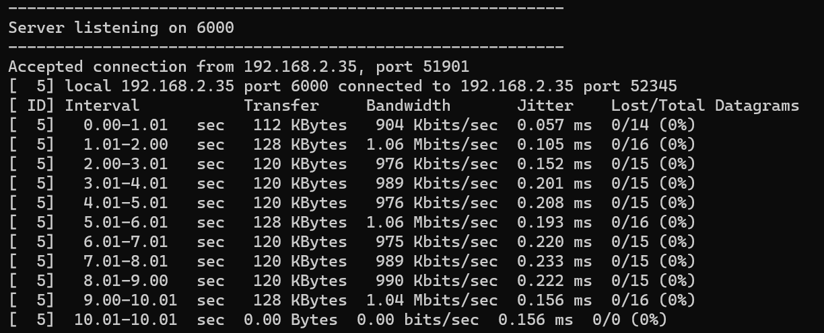

Figure 6: iPerf test - Server side

The same test was also successfully carried out on a smartphone at the same distance.

## Conclusion

The following table shows the differences between a 433 MHz RF transmission and a Wi-Fi communication:

|  |  |  |
| --- | --- | --- |
|  | **Wi-Fi** | **433 MHz RF** |
| Bandwidth | More than enough | Just enough |
| Range | enough | More than enough |
| Disturbed by interference | No (managed by CSMA/CA) | Yes |
| Connection to the computer | Wi-Fi / Ethernet | Serial port |
| Base station module | Wi-Fi Router | To be designed |
| Protocol | TCP/UDP | To be designed |

Table 1: Comparison between Wi-Fi and 433 MHz RF

The critical issues are the range and the ability to operate in an environment with a lot of interference.

The Wi-Fi solution is clearly better regarding its ability to deal with interference. The 433 MHz RF solution should be avoided because there will be many teams during the event, and communication without collision avoidance will likely fail.

For the range, the 433 MHz RF solution is better. However, the tests showed that the range was reachable with a classic Wi-Fi router.

Based on these two criteria, the Wi-Fi solution can already be selected. Moreover, the other points are all the better with this solution.

The system will therefore use Wi-Fi communication with Nordic Semiconductors' nRF7002 [6] module.

# Hardware development

## Bloc diagram

This diagram shows the general architecture of the telemetry system.

The main controller (nRF5340) is the central element of the system.

The CAN controller is connected to the nRF5340 via an SPI bus. On the other side, it is connected to the CAN bus to communicate with the BMS, the inverter, and all the sensors.

Another peripheral is the GPS module. It is connected to the nRF5340 via a UART communication. The GPS module uses an external antenna because it needs to be pointed to the sky, and the telemetry system will be placed in a case in the car.

The microSD card is connected to the nRF5340 via an SPI bus. The microSD card serves to store the measurements of the telemetry system. The memory card also holds a configuration file.

The nRF7002 chip handles Wi-Fi communication. It is connected to the nRF5340 via a QSPI bus. As for the GPS module, the Wi-Fi module uses an external antenna to improve the transmission.

The last peripheral is a UART interface. The telemetry system does not use it. It is just there for debugging purposes and future system improvements (to connect an onboard computer, for example).

## Main SoC

An SoC (System on Chip) needs to be chosen for the project. To start to program the telemetry system before the hardware is manufactured, the SoC must be available on a development kit. The Nordic nRF7002-DK is a development kit that integrates the Wi-Fi chip chosen in the Transmission Technology section. The host SoC of this kit is the nRF5340.

The nRF5340 is a high-performance SoC from Nordic Semiconductors. It integrates two Arm Cortex-M33 processors, Bluetooth, high-speed SPI/QSPI, and more great features. The application processor can be clocked at 64 or 128 MHz and optimized for performance. It has 1 Mbyte Flash and 512 Kbyte RAM. The network processor is clocked at 64 MHz and is optimized for low power and efficiency. It has 256 Kbyte Flash and 64 Kbyte RAM. The nRF5340 can integrate the Zephyr RTOS.

This processor is powerful enough for the system, and its availability in a development kit makes it the perfect choice.

The system will use the development kit with a custom PCB directly plugged into it to avoid spending too much time on hardware development.

Figure 7 : Development Kit

## GPS Module

Overview

The telemetry system needs to include a GNSS module. U-Blox is a leading provider of GNSS solutions. They produce high-quality positioning chips, modules, and antennas. Three GNSS solutions were studied.

The first is the SAM-M10Q module. It is an all-in-one module with an internal antenna. It has a UART and an I2C interface. Integrating this module into the design is easy and straightforward.

The second option is the MAX-M10S module. The specifications of this module are simi lar to the first module. It also has a UART and an I2C interface. It, however, does not have an internal antenna. This makes it less easy to integrate into the design because GNSS external antennas are active, and HF circuitry needs to be designed.

The last considered option is the UBX-M9140. It has two UART interfaces, one SPI, one I2C, and one USB interface. Unlike the two first options, this is not a module but a chip. It is much smaller than the modules, but the integration of this chip in the design is much more complicated.

These solutions are equivalent in terms of precision (standard precision). They all support concurrent reception of four GNSS (GPS, GLONASS, Galileo, and BeiDou). As the system will be placed in a housing in the car, the GNSS module needs to have an external antenna because it needs to be pointed at the sky. The first option is therefore not possible. As the system does not need to be extremely small, the second option (MAX-M10S) can be chosen to avoid spending too much time on developing the electronic schematics.

To work with this module, the ANN-MB antenna from the same manufacturer is the best option.

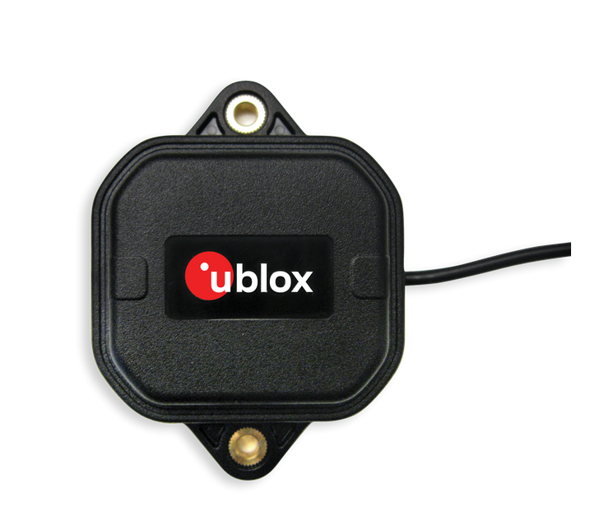

Figure 8 : GPS Antenna

Schematics

This schematic shows the circuitry of the GPS module. The module is connected to the nRF5340 using a UART communication.

On the RF side of the module, a circuit permits activating the antenna's power supply. The VCC_RF pin provides the antenna's power supply, and the LNA_EN pin provides the activation signal.

The jumper on the left side permits to isolate the module and links the UART port to a connector. This allows connecting the module directly to a computer and configuring the module with the U-Center software. Une image contenant texte, diagramme, Plan, schématique

The TX and RX pins are connected to the nRF 7002-DK by passing via a level shifter because the nRF provides 1.8 V signals, and the GPS module works with 3.3 V signals. Another UART interface also uses the level shifter. The telemetry system does not use it. It is just there for debugging purposes and future system improvements (to connect an onboard computer, for example).

## CAN Bus Controller

Overview

The telemetry system communicates with the sensors by the CAN bus. For this purpose, a CAN Controller must be selected. The MCP2515 is a CAN controller manufactured by Microchip. It has an SPI interface to relate to the main SoC. This module handles all functions for receiving and transmitting messages on the CAN Bus.

A CAN driver must be used to generate the CANH and CANL signals. The SN65HVD232 is a standard CAN driver. It just needs the txcan and rxcan signals to generate the CANH and CANL signals.

An inverter and other perturbating components are connected to the CAN Bus, so the system must integrate EMC protections.

Schematics

## SD card

## Power supply

## Level shifter

# Bibliography

[1] ‘FS-Rules_2023_v1.1.pdf’. Accessed: May 26, 2023. [Online]. Available: https://www.formulastudent.de/fileadmin/user_upload/all/2023/rules/FS-Rules_2023_v1.1.pdf

[2] ‘Valais Wallis Racing Team’. https://www.vrt-fs.ch/ (accessed May 26, 2023).

[3] ‘FS Alpe Adria - Home’. https://fs-alpeadria.com/ (accessed Jun. 15, 2023).

[4] ‘RFM69HC 20dBm Programmable 315-915Mhz RF Transceiver Module_Sub 1G Programmable 315-915Mhz RF Transceiver Module | HOPERF’. https://www.hoperf.com/modules/rf_transceiver/RFM69HCW.html (accessed May 26, 2023).

[5] ‘Friis transmission equation’, *Wikipedia*. May 25, 2023. Accessed: May 26, 2023. [Online]. Available: https://en.wikipedia.org/w/index.php?title=Friis_transmission_equation&oldid=1157035076

[6] ‘nRF7002 - Low-power, advanced security, seamless coexistence’. https://www.nordicsemi.com/Products/nRF7002 (accessed May 26, 2023).

[7] ‘Intel® Wi-Fi 6 AX201 (Gig+) - Caractéristiques du produit’, *Intel*. https://www.intel.fr/content/www/fr/fr/products/sku/130293/intel-wifi-6-ax201-gig/specifications.html (accessed May 26, 2023).

[8] ‘iPerf - The TCP, UDP and SCTP network bandwidth measurement tool’. https://iperf.fr/ (accessed May 26, 2023).

# Appendix

* Full planning